**Connecting SKIPR with THR36/42 in Bridge Mode**(reference: <https://github.com/makerbase-mks/MKS-THR36-THR42-UTC> )

**STEP1 –** Connect to the SKIPR board

In order to do anything, we first need to establish connection with the board. It’s important to understand that the SKIPR actually comprises 2 parts – one is the Host, which is essentially the part the runs the Linux OS and the other is the MCU, which is the microcontroller actually running your printer. Basically, the relationship between the 2 parts is the HOST runs Klipper software and tells the MCU what to do.

When we ‘connect’ to the SKIPR, we actually connect to the HOST. We have the option to connect over Wifi using SSH (Secure Shell Protocol) connection or over USB using Serial connection. We some sort of program installed on our PC that would allow us to connect. There are free programs that can be downloaded and used like PuTTY or Xshell. Xshell has the option to display the file manager which can be pretty handy.

**SSH connection**

First we need to connect the SKIPR to the same Wifi network as our PC. There are 2 ways we can do it:

**Through the config file on the TF card**

* Connect your TF card with system files to the PC.
* Open the "Boot" disk, find the file "**wpa_supplicant-wlan0.conf**" and open it in a text editor like Notepad++
* Modify the ssid (Wifi network name) and psk (Wifi Network password) to match your network, save the config file.
* Insert the TF card to the MKS SKIPR. It should connect to your Wifi network automatically.

**Through the Klipper screen**If you have a PI-TS35 or HDMI screen connected with MKS SKIPR, you can navigate to Network, find the Wifi network your wish to connect to, select it and enter the password. On older versions of KlipperScreen you won’t see on-screen keyboard to enter the password, you will have to connect an external keyboard to one of the Host USB ports. Note that from my experience, the last option won’t save the password after reboot and you will have to re-enter it each time.

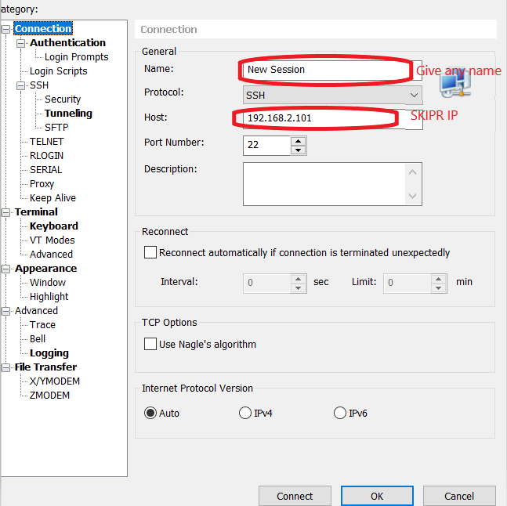After both SKIPR and the PC connected to the same Wifi network, connect to the SKIPR using a program like Xshell:  
When prompted for: the user name is **mks,** password is **makerbase**NOTE: Same can be done using PuTTY

**Serial Connection**

* Using a Type C USB cable connect the Host side to you PC.
* In the Device Manager on the PC find out the COM port number that has been assigned to the new connection
* 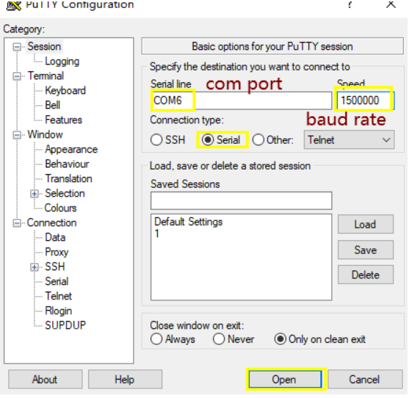In PuTTY Serial for connection type, enter the port number you found and a baude rate of 1500000. You can give a name to this connection and save it.
* 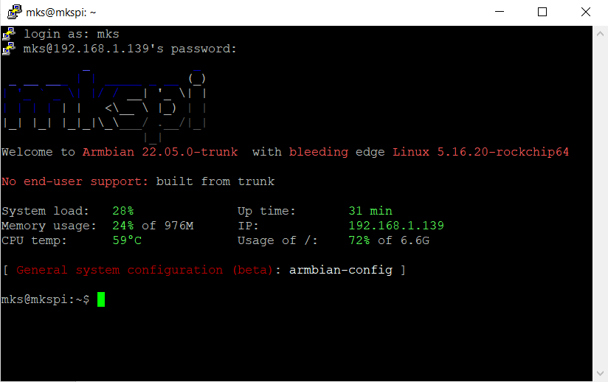Click Open. When connecting for the first time you will probably get a pop-up which you just have to accept. When prompted for User ID and Password, use these:  
  user: mks  
  password: makerbase  
  NOTE: Same can be done using Xshell

**STEP 2 –** Update Klipper to the latest

Older Klipper versions don’t have the CAN implemented correctly, so first we need to update it. Once you have connected and have the terminal open you can use commands to do things.

Remove MKS version of Klipper:

*rm –rf klipper*

Get the latest Klipper:

*git clone https://github.com/Klipper3d/klipper.git*

Go to Klipper directory:

*cd klipper*

Display menu:

*Make menuconfig*

Choose Linux for Architecture:  
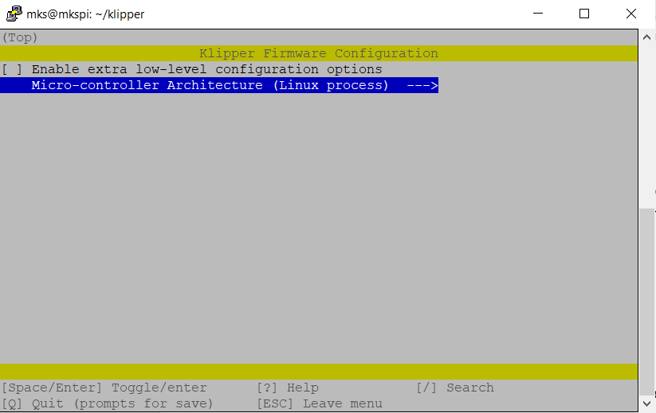

Hit ‘Q’ and approve saving. Now make the corresponding files:

*make*

Move the created files to the correct location:

*make flash*

**STEP3** - Flash the SKIPR to CAN Bridge Mode

Display menu:

*Make menuconfig*

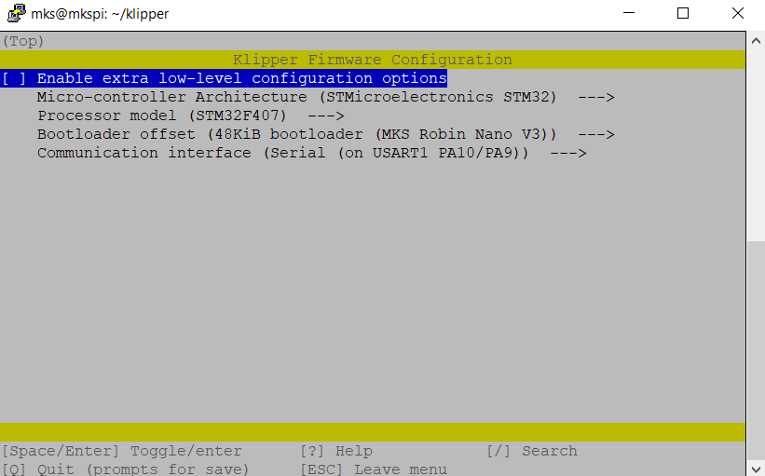Configure as follows:

Quit and save and then:

*make*

Now you will need to download out/klipper.bin to an SD card and rename it to mks_skipr.bin. If you are using Xshell for connection then you can choose to show the File Manager and download the file right from there.

Then put the SD card into the MCU SD card-slot and reboot the board. Give it several minutes to complete the flash. If the flash succeeded, then mks_skipr.cur should be now on the SD card.

Connect a USB-A to USB-C cable from the HOST to the MCU side of the SKIPR (bridge mode)

(Comment: The CAN connector on the SKIPR is Micro-Fit 3.0)

Create can0 file, by using this command:

*sudo nano /etc/network/interfaces.d/can0*

Put this inside the file:

*allow-hotplug can0  
iface can0 can static   
 bitrate 250000  
 up ifconfig $IFACE txqueuelen 128*

Save and exit.   
  
Query for CAN bus uuid:

*: ~/klippy-env/bin/python ~/klipper/scripts/canbus_query.py can0*

**You should get a response like this:

Connect to the board through a web browser by entering its IP in the address bar. Here from fluidd you have an easy access to printer.cfg. Add the uuid you just found into the [mcu] section:

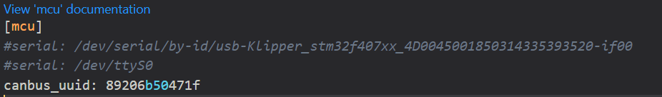

Restart firmware. If you have thermistors connected to the SKIPR board, then at this point Klipper should load and be ready.

**STEP 4** – Compile firmware for THR36 to CAN communication:

Display menu:

*Make menuconfig*

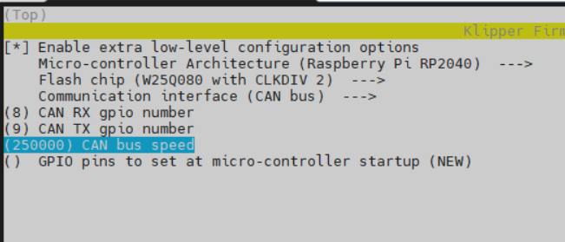Configure as follows:  
  
Quit and save and then:

*make*

Download the file “klipper.uf2” which which will be created under the "~/klipper/out/" directory.

While the THR36 is powered, connect it with a USB cable to the PC. The manual says “hold the boot button”, but what worked for me is press and release simultaneously the “boot” and “reset” buttons on the THR36. The PC will now recognize it as a storage device RPI_RP2 Disk.

Copy the downloaded file to this disk and it will automatically update the firmware.   
  
Now you need to create a MKS_THR.cfg file. You can simply copy it from here:

<https://github.com/makerbase-mks/MKS-THR36-THR42-UTC/blob/main/MKS_THR.cfg>

In the printer.cfg add [include MKS_THR.cfg]

Save and exit.

Connect THR36/42 to the SKIPR via CAN.

Comment: The CAN connector on the SKIPR is Micro-Fit 3.0

Query for CAN bus uuid:

*~/klippy-env/bin/python ~/klipper/scripts/canbus_query.py can0*

You should get the THR uuid.

Edit the MKS_THR.cfg and add under the [mcu MKS_THR]:

Canbus_uuid: *the uuid you found*

Save and reboot.